Javelin Variables Declaration and Usage

Javelin variables adds flexibility in flow and provides immense power at runtime. Variables are used to store values which can be used at runtime by activities. Variables can be initialized with a default value and can be loaded from various sources Database, File System etc.

Variables Window

Javelin variables window provides access to variables and allows user to add, delete or edit variable.

Add Variable
To add variable click on Create Variable and provide:
- Variable Name
  - Variable name should follow .NET naming guidelines
- Variable Type
  - Variable Type can be any .NET data type
- Scope
  - Scope depends on where variable needs to be used. Variable declared at outer scope are available in flowcharts in inner scope but vice-versa is not allowed
- Default Value
  - Provide a default value to a variable
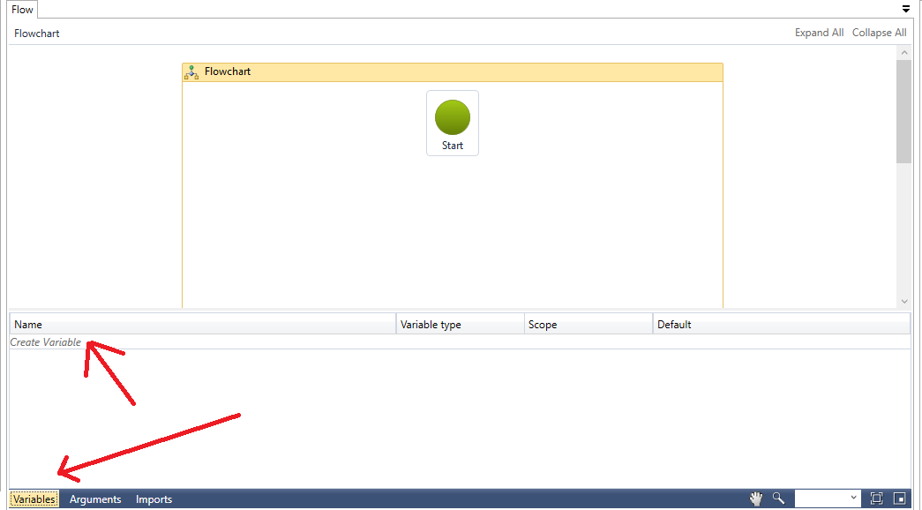

Variable Assignment
Variables can be assigned using Assign Activity or can be assigned as an output from any activity like DataTable can be assigned value as part of Select statement execution from a database activity or string content can be assigned from FileOperation (ReadText) activity. Once value is assigned variable value will be retained in the flow or can be reassigned a new value.

Variable Usage
Based on type of variable its usage differs e.g. string values can be concatenated with string or DataTable can be used to navigate through Rows and Columns of the output of select statement.

Sample Flow
Add a string variable and assign value by reading content of a file and concatenate variable with static string and log the concatenated string
- Declare a variable named CLIENT_ID with empty default value
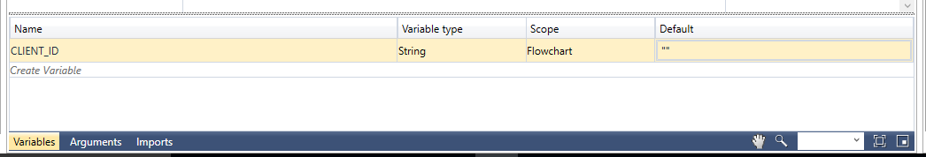
- Drag File Operation activity from File System group in Toolbox and connect it with Start
- Select ReadAllText action from Action Dropdown
- Specify path of file from which content will be read and assigned to variable
- In ReadText output property specify CLIENT_ID that was created in step 1
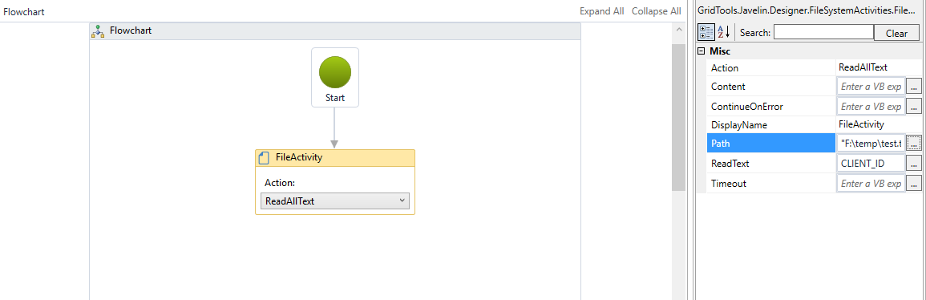
- From Control Flow group in Toolbox drop Log activity and connect it from FileActivity
- In MessageToLog property write: "Client ID is: " & CLIENT_ID
  - & is used to concatenate strings in Javelin which support VB.NET syntax in Expression Editor
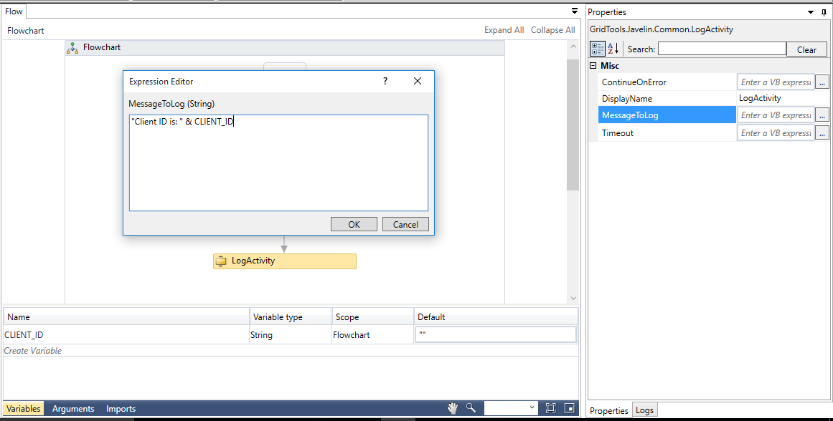

Executing the flow will write in log:
Client ID is: 4 where 4 is the variable value which was read from the file.

